Webmail Interface

📧 What Is the Webmail Interface Component in a Mail Server System?
# Source: AI Source: Provided by: [Data Path: Persons Table -> ID Column: 1, Name_En Column: Motasem Essam] -> From: [ChatGPT] on [1/21/2026]
The Webmail Interface is a component that allows users to access their email through a web browser — no special email software (like Outlook or Thunderbird) is required.
It provides a graphical interface (GUI) to read, send, organize, and manage emails online, just like Gmail or Yahoo Mail.

🧠 Why It's Important
# Source: AI Source: Provided by: [Data Path: Persons Table -> ID Column: 1, Name_En Column: Motasem Essam] -> From: [ChatGPT] on [1/21/2026]
- ✅ No installation needed — just open a browser.
- ✅ Works from any device, anywhere.
- ✅ Useful in corporate or university environments with centralized access.
- ✅ Offers a user-friendly alternative to desktop or mobile email clients.

🔁 How It Fits Into a Mail Server
# Source: AI Source: Provided by: [Data Path: Persons Table -> ID Column: 1, Name_En Column: Motasem Essam] -> From: [ChatGPT] on [1/21/2026]
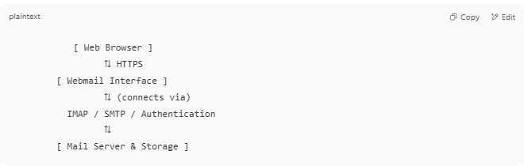

[ Web Browser ]
⇅ HTTPS
[ Webmail Interface ]
⇅ (connects via)
IMAP / SMTP / Authentication
⇅
[ Mail Server & Storage ]

🔐 Common Features in Webmail Interfaces
# Source: AI Source: Provided by: [Data Path: Persons Table -> ID Column: 1, Name_En Column: Motasem Essam] -> From: [ChatGPT] on [1/21/2026]
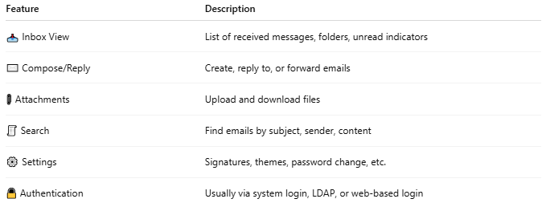

Feature | Description
📥 Inbox View | List of received messages, folders, unread indicators
✉️ Compose/Reply | Create, reply to, or forward emails
📎 Attachments | Upload and download files
🧾 Search | Find emails by subject, sender, content
⚙️ Settings | Signatures, themes, password change, etc.
🔒 Authentication | Usually via system login, LDAP, or web-based login

🧰 Examples of Webmail Software
# Source: AI Source: Provided by: [Data Path: Persons Table -> ID Column: 1, Name_En Column: Motasem Essam] -> From: [ChatGPT] on [1/21/2026]
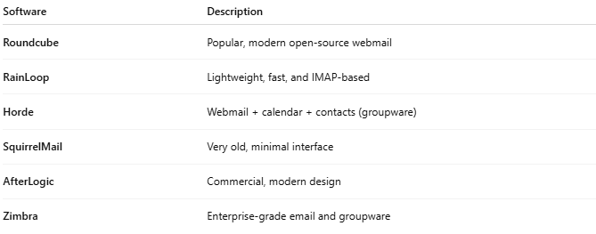

Software | Description
Roundcube | Popular, modern open-source webmail
RainLoop | Lightweight, fast, and IMAP-based
Horde | Webmail + calendar + contacts (groupware)
SquirrelMail | Very old, minimal interface
AfterLogic | Commercial, modern design
Zimbra | Enterprise-grade email and groupware

✅ Summary
# Source: AI Source: Provided by: [Data Path: Persons Table -> ID Column: 1, Name_En Column: Motasem Essam] -> From: [ChatGPT] on [1/21/2026]
The Webmail Interface is the browser-based front end of an email system that lets users manage their messages without installing any software.
It acts like a web-based email client and connects to the mail server using IMAP/SMTP behind the scenes.

